Gospel Conversations
Sharing the Gospel in a Changing Culture
Acts 2:5, 22-42 Acts 17:17-34

3 Vignettes: College age people from California: Wendy, Jason, Kevin

Favorite engagement question: Do you have any particular spiritual beliefs?

Understanding the Culture has changed

What was the culture of Acts 2?

v 38 Peter: Repent and be baptized in the name of Jesus Christ
x
|--------------------------------------------------------------------------------------------------|
1 (No knowledge of God) (Knowledge of God) 10

What was the culture of Acts 17?

v 23 Paul: I found an altar with this inscription, TO AN UNKNOWN GOD
x
|--------------------------------------------------------------------------------------------------|
1 (No knowledge of God) (Knowledge of God) 10

Where are people on the spiritual scale? Spiritual beliefs ?

The Rise of the Nones by James Emery White *

www.ViewTheStory.com
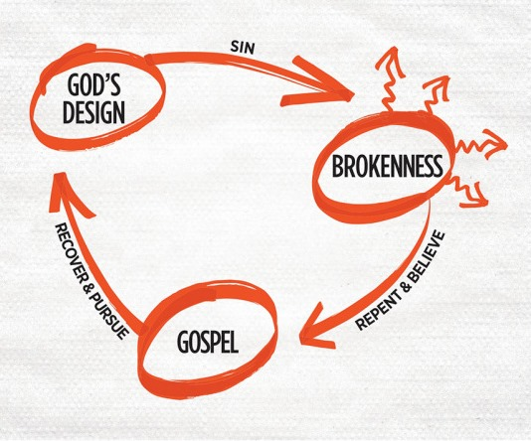
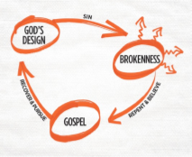

THE STORY: Creation – The Fall – Rescue – Restoration / Redemption
3 Circles - North American Mission Board
The 3 Story Method
- Listen to their story
- Tell them your story
- Tell them His Story

An interview with a Wiccan – The Story of Thurman from Nashville, TN

Martin H. Dupree Chief Consultant, TheJasper.Foundation www.MartyDupree.org

